;l

Foundations of Programming

Assignment No. : 4
PROBLEM STATEMENT: Write a C Program to calculate the salary of an employee given his basic pay (taken as input from the user). Calculate gross salary of employee. Let HRA be 10 % of basic pay and TA be 5% of basic pay. Let employees pay professional tax as 2% of total salary. Calculate net salary payable after deductions.

OBJECTIVE:

- To understand the importance of flowchart for any programming model.
- To learn simple flowchart symbols and arrows to define relationships.
- To understand and develop visual representations of flow of data.

THEORY:

1. Definition of Algorithm

An algorithm is a finite sequence of well-defined, clear, and unambiguous steps used to solve a specific problem or to perform a particular task. Each step of an algorithm must be executed in a systematic order to obtain the desired output from the given input.

In computer programming, an algorithm serves as a logical blueprint for writing a program. It describes what needs to be done step by step before converting the solution into a programming language.

Key Points in Definition

Step-by-step procedure

Finite number of steps

Clear and precise instructions

Converts input into output

2. Characteristics of an Algorithm

Input

An algorithm must accept zero or more inputs. These inputs are the data values supplied to the algorithm for processing.

Example:
Two numbers a and b given as input for addition.

Output

An algorithm must produce at least one output. The output is the result obtained after executing the algorithm.

Example:
Sum of two numbers as output.

Definiteness

Each step of the algorithm must be clearly defined and unambiguous. There should be no confusion regarding what action is to be performed at every step.

Example:
Instead of saying “process the number,” say “add 5 to the number.”

Finiteness

An algorithm must terminate after a finite number of steps. It should not run indefinitely.

Example:
A loop that runs from 1 to 10 is finite.

Effectiveness

All operations in an algorithm must be simple, executable, and feasible within a reasonable amount of time using available resources.

Example:
Basic arithmetic operations like addition and multiplication are effective.

Correctness

The algorithm must produce correct output for all valid inputs. Correctness ensures the reliability of the algorithm.

Generality

An algorithm should be general enough to handle all valid inputs related to the problem, not just a specific case.

Example:
An algorithm to find the largest number should work for any set of numbers.

ALGORITHM :

Start

Declare variables B, H, G, X, T, N

Input the basic pay from the user and store in B.

Calculate HRA = 10% of basic pay

H = 0.1*B

Calculate TA = 5% of basic pay

T = 0.05*B

Calculate gross salary

G = B + H+ T

Calculate Professional tax = X = 0.02 * G

Calculate net salary = G- X

Display H, T, G, X, N.

Stop
FLOWCHART:
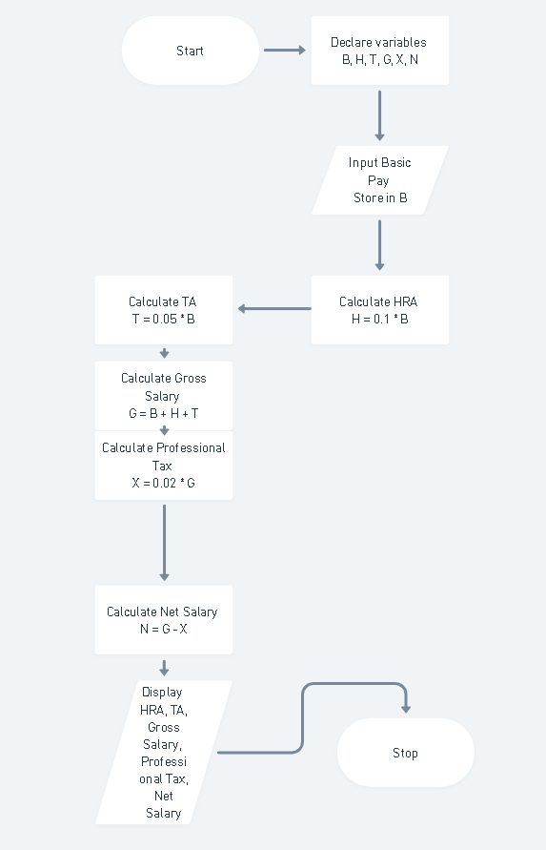
PLATFORM: Linux

INPUT/ OUTPUT:
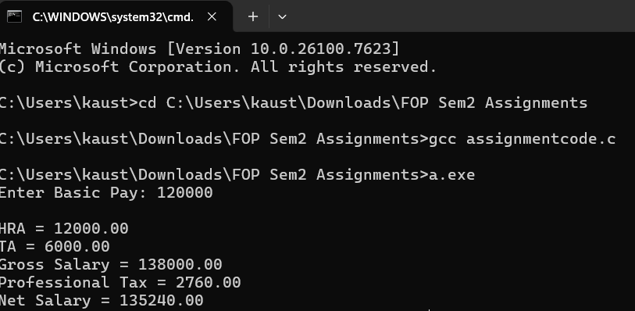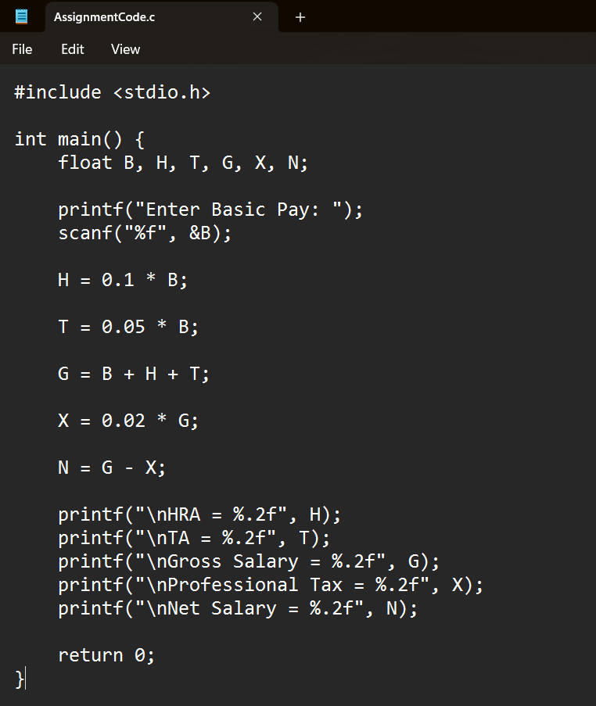

CONCLUSION: Thus, we have learned to write algorithms and to draw its representation in terms of flowchart.

